SunPrints Website Database

Offline setup for laptops

Please read carefully

Note: The latest version of this document is always available at a link on the home page, or at s:\sunprints\how to install on laptop.docx. If you got this document from somewhere else, you need to get the latest version instead.

Part A: Install

These steps only need to be done once per computer.

1. Download the node.js software <https://nodejs.org/dist/v16.17.0/node-v16.17.0-win-x64.zip>

2. Extract the contents of the zip file to a folder on c: drive. You should end up with a folder on c: drive named c:\node-v16.17.0-win-x64 Before continuing, verify this.

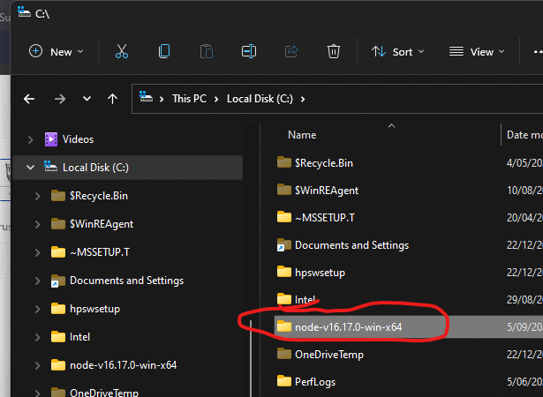

3. Create another new folder named "c:\sunprintsweb"

4. Copy all the files from s:\website to c:\sunprintsweb.

**WARNING:** These files on s:\website are the live server. Do not delete or alter any of these files.

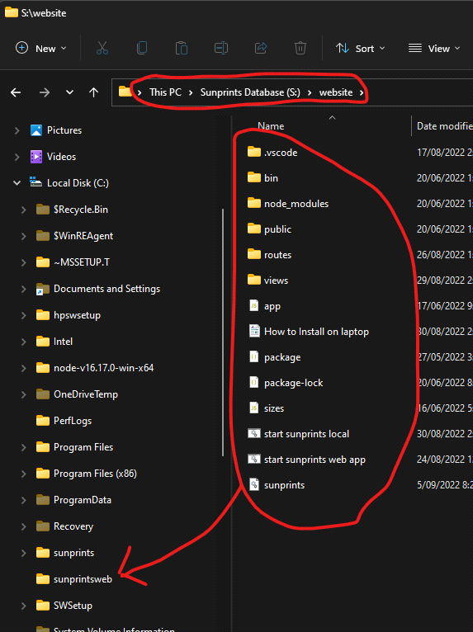

Part B: Running locally

Start the server by double clicking the “start sunprints local” command

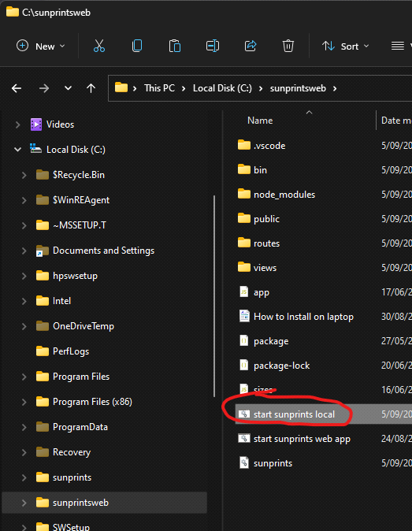

If you see a firewall warning message, such as this, click cancel

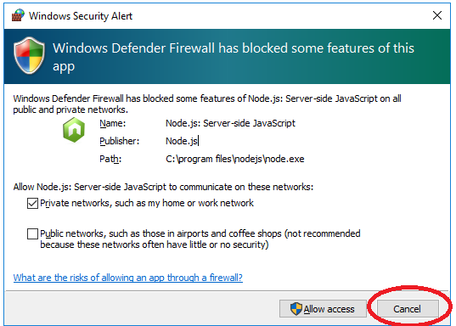

You should now see another command prompt window.

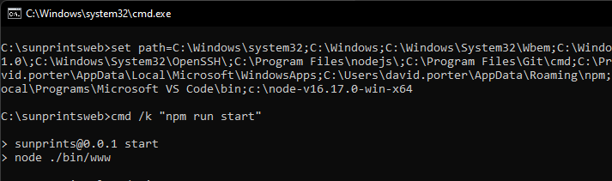

**Leave this window open.** As long as it is open, you will be able to access the local running website.

Now you can point your browser to the server which is running on localhost (that is, your local pc)

[http://localhost:3000](http://localhost:3000/)

When you are running on your local pc, you will see a message: Running on local server — Not Live Data

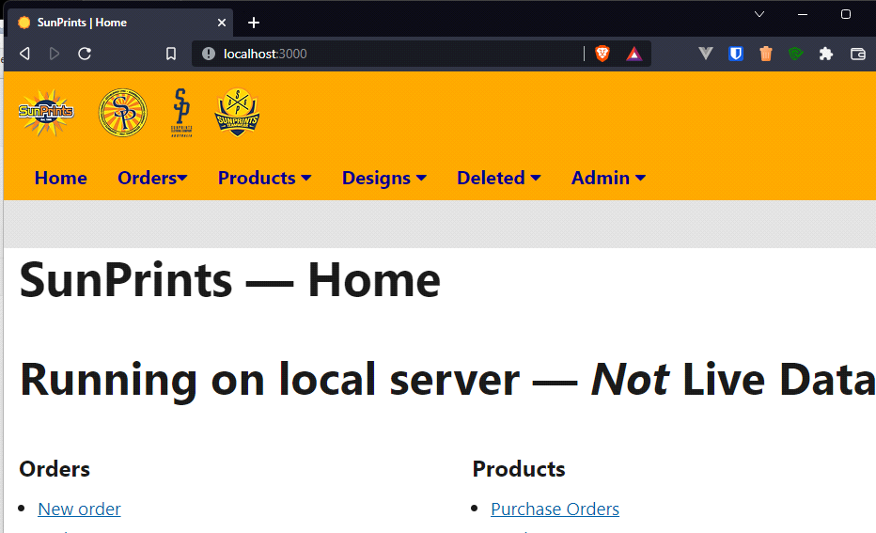

Running locally like this is only intended for looking up details such as customer details orders. You can save changes, but they will not be synchronised with the main database.

C: Updating the database

You can refresh your local database by copying the sunprints.db file from s:\website to your folder c:\sunprintsweb

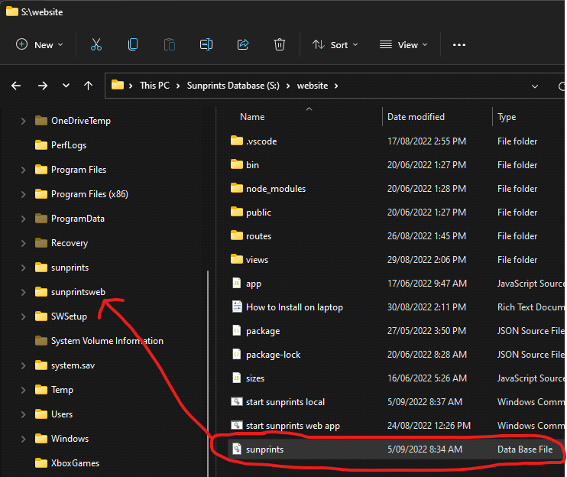

D. Updating the application

From time to time to updates are made to the web application and you might want to copy these updates to your own local install.

1. If you have the command prompt window already open from part B previously, close it.

1. Repeat Part A, step 4. Copy all the files from s:\website to c:\sunprintsweb.

2. Do Part B again, double clicking the command at “c:\sunprintsweb\start sunprints local”

3. Refresh your browser window (F5).